October 29th, 2006
Hi
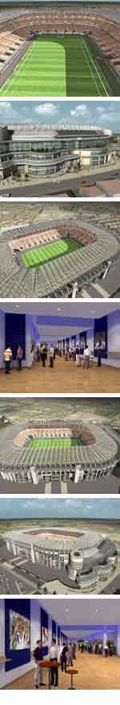
Again there is not much to write about this week. I went to the clinic to get the results for the two biopsies on my back from several weeks ago. Both came back BCC, and one of the two had ‘Bowen's disease’ referring to pre-cancerous squamous cells (another kind of skin cell) which are not cancerous now but could be in the future and could spread. As the lesions were small, the biopsies actually removed all of the infected tissue. There are other areas that could be suspect including a pimple-like thing with redness on one hand and a red mark on my face. The dermatologist suggested treatment by either freeing them out with liquid nitrogen or using a cream. Either would be OK with me but I chose the cream. I will start applying it tomorrow. On application, the cream is quickly absorbed into the body and does something to cause the body to attack those areas. There could be side effects with swelling, pus, etc. We will see.
Only did exercise three days this week. A slow run at just 9 km/h on one day and just a 1.5 km swim on another of the three days. I am exhausted so decided to have about a week off. The cooler season mountain runs will start again in a couple of weeks.
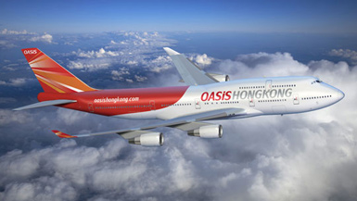
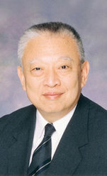
In HK. the annual government awards have been dished out. Tung Chee Hwa received HK's highest award the ‘Golden Bauhinia Medal’ just for being the first Chief Executive! HK's new budget airline - Oasis – was to have had its inaugural flight the other day. But it didn’t happen as permission to fly over Russia denied at the last minute. The plane was sitting on the tarmac for about 6 hours with about 350 passengers on board waiting for permission, which eventually came, but a few hours after its was decided to postpone the flight. The flight eventually got off the ground the next day. Oasis has one plane, a 747, for flights between HK and London. Tickets are ridiculously cheap (?? about HK$1000 one way) and they have already they have sold 20 000 tickets. The Lantau cable car packed up = again – for about 4 hours one day.
The Northern hemisphere international Rugby matches begin soon. The first is between England and the All Blacks in London on November 5th (which is ‘Guy Fawkes’ day so I expect there will be fireworks – get it?) This is a special match for the opening of a new stand at Twickenham. The photo strip on the right so pictures of Twickenham; I only wanted one picture but had to take the lot.

That’s about it.
Cheers

